1. Source Codes

view-latihan2.php > application/views

Model1.php > application/model

Latihan1.php > application/controllers

Latihan2.php > application/controllers

1. URL

http://localhost/pustakabooking/index.php/Latihan1/penjumlahan/08/03 http://localhost/pustakabooking/index.php/Latihan2/penjumlahan/08/03

1. Screenshot

* Latihan 1

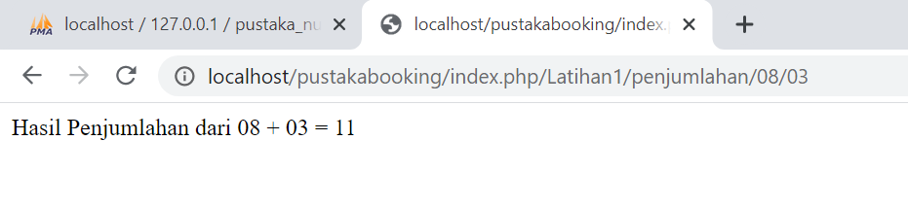

* Latihan 2

